|  |  |
| --- | --- |
| **Completing our Accounts Payable Forms (including overseas payments)** | |
| If you are due a payment (i.e. you are a student/supplier) or you are in a school/department and need to raise a request for a payment, you will need to complete a Finance form. Each of our finance forms can be used to make payment but you will need select the correct form depending on and what you are paying/being paid. Please see our quick guide to forms in Appendix 3.  For a quick and successful payment, you will need to provide payee details, payment details i.e. amount and currency and bank details for recipient. The form also needs to include costing information, this information is always completed by the School/Department not the student/supplier. This guidance document will help you complete the sections of our finance forms (although some forms can vary in layout, the majority of payment information is the same).  If you have any queries relating to our finance forms, processes or require our documents in an alternative format, please email [finance.helpline@ed.ac.uk](mailto:finance.helpline@ed.ac.uk) marked for the attention of Service Assurance and a member of the team will get back to you. | |
| Basic form fields and information requirements | |
| |  |  | | --- | --- | | 1. **Payee details** | | | Payee name: | Should match the payee name for the bank account information. | | Email address: | Always required to generate a remittance advice confirming payment. | | Home Address: | This should be the address the bank account is registered to but can be left blank for payments to students | | Supplier no: | A supplier record needs to be created before a payment can be made, the School/Department will add this number. See supplier creation guidance. | | 1. **Payment Details** | | | Payment amount | This is how much is due to be paid to the payee in the currency specified. Refer to converting currencies guidance. | | Payment Currency | Refer to the currency list in Appendix 1 for currencies we can pay in. The currency you add will depend on the country of your bank i.e. UK = GBP. Please ensure you check what currency the beneficiary bank account is held in to avoid potential unnecessary foreign exchange by the beneficiary bank. | | 1. **Bank details of recipient** | | | Name on account: | Beneficiary account name - we need the full correct bank account holders name | | Bank/Building Society name: | Beneficiary bank's name | | Branch address: | Bank branch address (the bank address is not required where an IBAN is provided). Please ensure you check what currency the beneficiary bank account is held in to avoid potential unnecessary foreign exchange by the beneficiary bank. You can refer to our “bank information required per country” table provided below as a guide to what information you need to provide. | | Account number/roll number | See Appendix 2 for bank information required per country | | IBAN (also known as BIC) | See Appendix 2 for bank information required per country (not required for UK bank accounts) | | SWIFT | See Appendix 2 for bank information required per country (not required for UK bank accounts) | | IFSC number or account type | See Appendix 2 for bank information required per country (not required for UK bank accounts) | | Routing or transit number | You can use this field to enter as much additional payment information as you can i.e. routing/transit number, intermediary details (if applicable). |   The School/Department will complete the costing section. A list of all bank branches currently held in People and Money can be found here: [Bank Branches List](https://uoe.sharepoint.com/:x:/r/sites/FinanceOperations/Shared%20Documents/Accounts%20Payable%20Guides/Other%20documents/Bank%20Branches%20Export.xlsx?d=w53e6fa26c16648cbb9da32acafa834f5&csf=1&web=1&e=GRLCeM). | |
| Supplier creation guidance – information for Schools/Departments | |
| A **non-trade/student supplier record** needs to be created to facilitate payment where Procurement is not responsible for initiating the process. This is typically in circumstances where a requisition request and subsequent Purchase Order would not be or is not expected to be raised i.e. exceptions to the ‘no PO no pay’ policy.  You should check if a supplier record already exists before completing a payment request form ([see supplier list](https://uoe.sharepoint.com/sites/FinanceOperations/Shared%20Documents/Forms/AllItems.aspx?csf=1&web=1&e=mBo1hQ&CID=8f5cd81c-a084-48e9-9ce8-0cf87a438bb7&FolderCTID=0x012000EC9957AB06871E40BB32A45CFC8539AD&id=/sites/FinanceOperations/Shared+Documents/Supplier+List)). If the supplier number is on the list enter the supplier number on the relevant finance payment request form. If the supplier doesn't already exist, you should follow the guidance below;  **For student supplier record changes/creations:**  **Send this link to students who have a UK bank account:**<https://edin.ac/finance-student-bank-details>. Once the student completes and submits the form, Accounts Payable will check the supplier record and either update the students bank details or create a supplier record. When a supplier is created the supplier number will appear on the supplier list within 1-2 days of submission.  **Send this link to students who have a non-UK bank account**<https://edin.ac/finance-student-bank-details-non-UK>. Once the student completes and submits the form, Accounts Payable will check the supplier record and either update the students bank details or create a supplier record. When a supplier is created the supplier number will appear on the supplier list within 1-2 days of submission.  **For non-trade payments (i.e., all other payees receiving a non-PO payment):**  If the supplier is not on the supplier list, simply leave the supplier number blank on the finance form and the Accounts Payable team will create the supplier record.  Accounts Payable will monitor each stage of the creation process and validate the new supplier details with emphasis on the validity of any bank account information or payment attributes. In the event that details are inaccurate, or updates require confirming, the originator is informed of the request status and payment readiness - this may result in a payment delay.  Accounts Payable will manage any changes to bank account details should the finance form contain different payment information. | |
| Converting currencies | |
| Supplier payments are made in UK pounds sterling (GBP) except where there are unavoidable operational reasons for a payment to be made in a foreign currency, including where the recipient bank account will only accept payment in a particular currency. Foreign currency payments are usually made on a Tuesday and Thursday. Payments typically take up to 5 working days to arrive in a recipients' account (but can take a little bit longer for overseas payments depending on what country you are paying to and the intermediary banks involved).  Recipients of overseas payments may not receive the exact same value into their bank account as the value that was sent from the University. This can be due to currency exchange rates, the need for banks to convert our payment into the currency of the bank account or a handling fee by the recipient or intermediary banks. Bank charges are not taken by the University's bankers and we have no prior knowledge of when a bank fee will be incurred. We advise that recipients are made aware that there is the potential that a bank fee may be incurred and therefore they may receive less into their bank account than the value of the claim/invoice they submit for reimbursement/payment. If you wish to cover conversion charges/bank fees, these can be added as additional amount to the payment. As the University does not know when a bank fee may be incurred, we cannot advise how much would need to be added but potential charges can range from $15-$25. As there is no guarantee that a charge would be applied, the amount would be paid directly to the recipient of the payment and be met by the departmental budget.  **If the claim is to be paid to a UK bank account,** any foreign currency claims should be converted to sterling (GBP) at the nearest applicable exchange rate on the date of the transaction and claimed in sterling (GBP) “including any charges”.  **If the claim is to be paid to an overseas account,** you should convert the claim to the relevant currency accepted by your bank (i.e. to make a payment to an account held in Germany claims should be paid in EUROS).  You can use: [xe.com](https://eur02.safelinks.protection.outlook.com/?url=https%3A%2F%2Fwww.xe.com%2F&data=05%7C02%7C%7C2ecf4df1b5064be1aa3b08dd76b3ab50%7C2e9f06b016694589878910a06934dc61%7C0%7C0%7C638797236231642387%7CUnknown%7CTWFpbGZsb3d8eyJFbXB0eU1hcGkiOnRydWUsIlYiOiIwLjAuMDAwMCIsIlAiOiJXaW4zMiIsIkFOIjoiTWFpbCIsIldUIjoyfQ%3D%3D%7C0%7C%7C%7C&sdata=OJ2%2BbO5n3Zj7HmBO%2Bcxazrhz6BjQnocCv1gg2FPSvJY%3D&reserved=0) to convert the transaction or attach an image of the transaction from your bank statement for evidencing the claim value **or;**  **As an alternative to completing any conversion calculations,** you can simply enter the sum you are claiming in the original currency. Just confirm what currency you would like the payment to be made in (again it must match the currency accepted by your bank) and our Finance System can convert the payment using a built-in currency convertor tool. We will let you know how much is being paid via a BACS remittance advice which will be emailed when the payment has been made. | |
| Appendix 1 – currency list | |
| We can only make payments in currencies supported by our Finance System if the payment currency you select for payment isn’t supported, you should default to EUR, USD or GBP. Supported currency options can be found below.  *Please note, payments in CNY cannot be made to individuals residing in China as per Chinese law. Payments in CNY to companies, however, are accepted. | |
| **Currency Name** | **Currency Code** |
| AUSTRALIAN DOLLARS | AUD |
| BAHRAIN DINARS | BHD |
| BARBADOS DOLLARS | BBD |
| BERMUDA DOLLARS | BMD |
| BULGARIA LEVA | BGN |
| CANADIAN DOLLARS | CAD |
| CHINESE RENMINBI* | CNY |
| CROATIA KUNA | HRK |
| CZECH REPUBLIC KORUNY | CZK |
| DANISH KRONER | DKK |
| EURO | EUR |
| HONG KONG DOLLARS | HKD |
| HUNGARY FORINT | HUF |
| INDIA RUPEES | INR |
| ISRAEL NEW SHEKELS | ILS |
| JAPANESE YEN | JPY |
| JORDAN DINARS | JOD |
| KENYA SHILLINGS | KES |
| KUWAIT DINARS | KWD |
| MAURITIUS RUPEE | MUR |
| MOROCCO DIRHAM | MAD |
| NETHERLANDS ANTILLES GUILDER | ANG |
| NEW ZEALAND DOLLARS | NZD |
| NORWEGIAN KRONER | NOK |
| OMAN RIAL | OMR |
| POLAND ZLOTY | PLN |
| QATAR RIYAL | QAR |
| SAUDI ARABIA RIYAL | SAR |
| SINGAPORE DOLLARS | SGD |
| SOUTH AFRICAN RAND | ZAR |
| SWEDISH KRONA | SEK |
| SWISS FRANCS | CHF |
| TANZANIA SHILLING | TZS |
| THAILAND BAHT | THB |
| TUNISIA DINAR | TND |
| TURKEY LIRA | TRY |
| UAE DIRHAM | AED |
| US DOLLARS | USD |

Appendix 2 – Bank account information per country 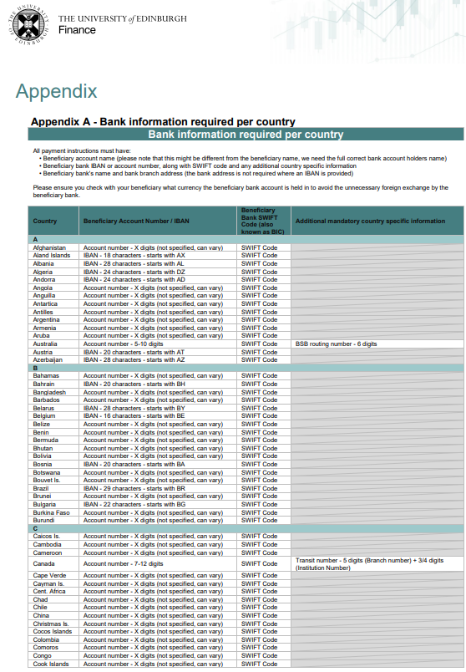

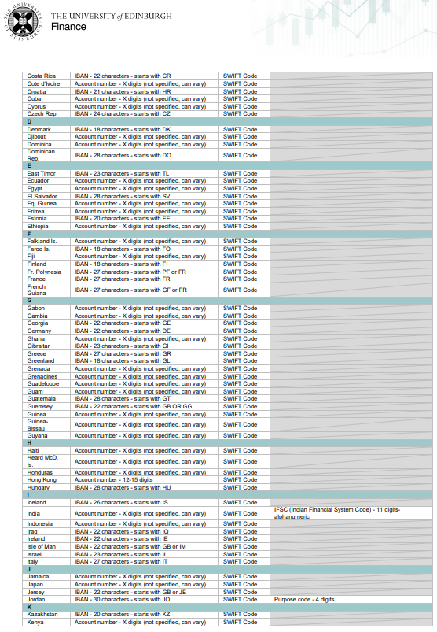

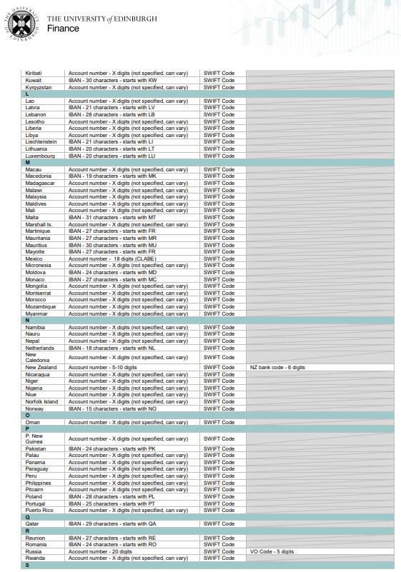

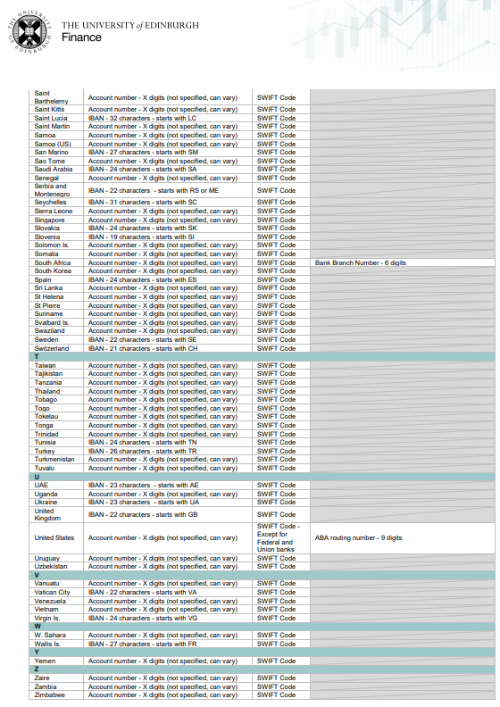

|  |  |  |  |  |  |  |  |  |
| --- | --- | --- | --- | --- | --- | --- | --- | --- |
| Appendix 3 – summary of forms | | | | | | | | |
| **Summary of payment types v’s payment methods** | | | | | | | | |
| **Payment type** | **Accounts Payable (via an invoice)** | **Accounts Payable (via Finance Form)** | **Expenses (claimed via P&M)** | **Corporate Credit Card** | **Cash distribution from Cash & Banking Team** | **Payroll Services Team** | **Tax assessment required (if paying for provision of services)** | Finance form required *only to be used when payment has been assessed and deemed non-taxable/paid by Accounts Payable |
| Goods & Services (via Purchase Order) | X |  |  |  |  |  |  | N/A |
| Travel booked via Travel Management Company | X |  |  |  |  |  |  | N/A |
| Travel exemptions |  |  | X | X |  |  |  | N/A |
| Other purchasing exemptions * defined in PO section |  |  | X | X |  |  |  | N/A |
| Staff expenses/advance of expenses |  |  | X |  |  |  |  | N/A |
| Student expenses |  | X |  |  |  |  |  | Student Expenses Claim Form (word or excel option) |
| Non-staff expenses |  | X |  |  |  |  |  | Non-Staff Expenses Claim Form |
| Student advance of expenses |  | X |  |  |  |  |  | Advances of Expenses for Students |
| Cash distribution by Cash and Banking Team (by exception only) |  |  |  |  | X |  |  | Cash Payment Request – Non Petty Cash |
| Paying a Non-PO supplier invoice(received from supplier) *includes VAT fields |  | x |  |  |  |  |  | Non-PO Supplier Payment Request Form |
| Payments to visiting instructors, teachers, lecturers or speakers |  | *If deemed non-taxable |  |  |  | *If deemed taxable | Yes | Accounts Payable Payment Request Form |
| Payments to students, volunteers, voluntary workers and interns (over and above out of pocket expenses) |  | *If deemed non-taxable |  |  |  | *If deemed taxable | Yes | Accounts Payable Payment Request Form |
| Payments to external examiners |  | *If deemed non-taxable |  |  |  | *If deemed taxable | Yes | Non-Taxable External Examiners Timesheet |
| Payments to visiting academics (over and above of pocket expenses) |  | *If deemed non-taxable |  |  |  | *If deemed taxable | Yes | Accounts Payable Payment Request Form |
| Paying research and non-research related participation payments |  | *If deemed non-taxable |  |  |  | *If deemed taxable | Yes | [Guidance for Paying Research Participants](https://uoe.sharepoint.com/sites/FinanceOperations/SitePages/Research-Payments.aspx) |
| Paying members of the public for involvement in health care & research |  | *If deemed non-taxable |  |  |  | *If deemed taxable | Yes | [Guidance for Public Involvement in Health and Care Research](https://uoe.sharepoint.com/sites/FinanceOperations/SitePages/Guidance-for-Public-Involvement-in-Health-and-Care-Research.aspx) |
| Paying one off payment to an individual for services <£500 |  | *If deemed appropriate |  |  |  |  | Yes | Single payment in a tax year form |
| Multiple supplier creations/invoices |  | *If deemed appropriate/non-taxable |  |  |  |  | Yes | [Invoice uploader template](https://www.ed.ac.uk/sites/default/files/atoms/files/invoice_spreadsheet_uploader_template_0.xlsx)  [Student supplier Creation Template](https://www.ed.ac.uk/sites/default/files/atoms/files/student_supplier_creation_template_1.xlsx)  Non-Trade supplier Creation Template |
| University initiated payments i.e. stipends, bursaries, awards, prizes |  | *If deemed non-taxable |  |  |  | *If deemed taxable | Yes | Accounts Payable Payment Request Form |
| Non-Taxable Scholarships (recurring payments) |  | *If deemed non-taxable |  |  |  | *If deemed taxable | Yes | Non-Taxable Scholarship Payment Form (or recurring template) |
| All forms can be found on our Finance Forms page: [Finance Forms | Finance](https://uoe-finance.ed.ac.uk/for-staff/forms). You should always refer to our Accounts Payable SharePoint site for guidance on making payments including pay run information and managing escalations: [Accounts Payable](https://uoe.sharepoint.com/sites/FinanceOperations/SitePages/Accounts-Payable.aspx) | | | | | | | | |