Paying student academic fees by bank transfer

‘Student academic fees’ refer to tuition fees and any additional programme costs.
You need to confirm your funding or arrange payment of your student academic fees when you complete your online student registration. If you wish to pay before the online registration opens, or if payment could not be taken during registration, you will be able to pay through My Finance channel in MyEd.
This guide takes provides instructions on how to complete payment by bank transfer and it is divided into 2 sections:
Section A: How to pay by bank transfer during online student registration.
Section B: How to pay by bank transfer through the My finance channel in MyEd.
Follow the section that applies to when you are making your payment.
Note, student academic fee amounts shown in this guide are provided as examples for demonstration purposes only.

Section A: Paying student academic fees as part of online student registration

- Once the registration opens (you will receive an email reminder), Log in to My Student Record/EUCLID using your University login details. Select ‘Start Registration’ to begin the registration process.
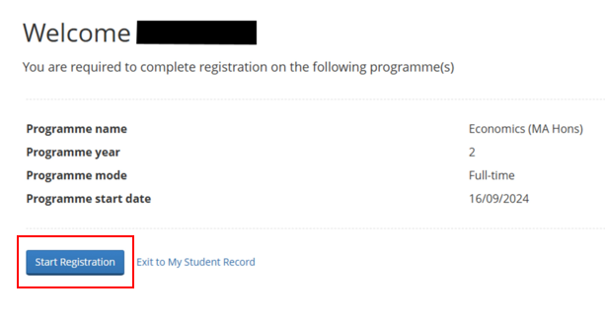

- Finish all previous parts of the online registration form before completing the Academic Fees and Payment section.

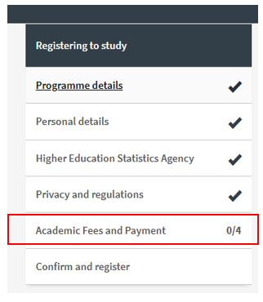

- In the Academic Fees and Payment section complete the loan and funding questions and confirm your fee details. This will allow you to continue to the payment step.

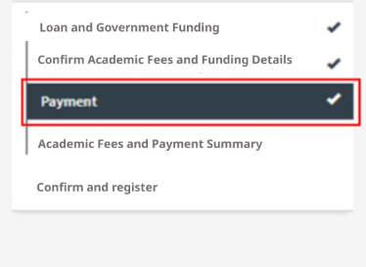

- You will be shown the breakdown of your student academic fees for the current academic year and the amount payable by you. To pay by bank transfer, select ‘Pay now by bank transfer’.
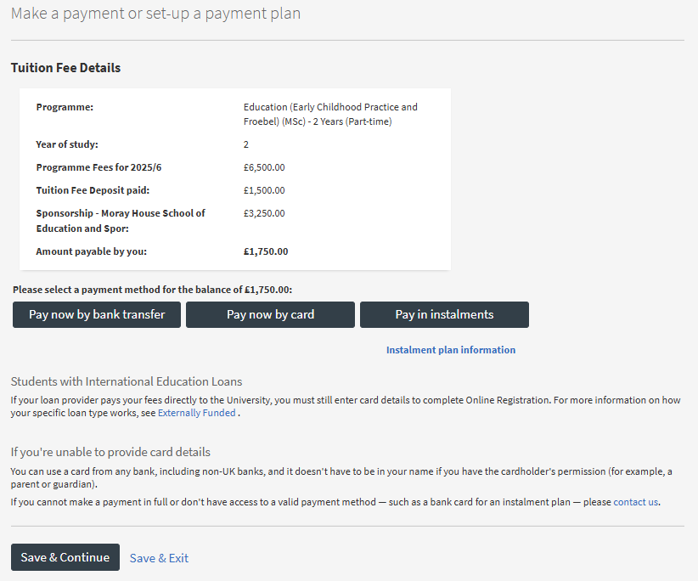

- Payment process is the same as when paying through My Finance channel in MyEd.
Refer to Section B, Step 6 onward, for the full payment instructions.

- Once you have completed your payment process, you will receive a confirmation message and be able to complete the final step of the online registration process.

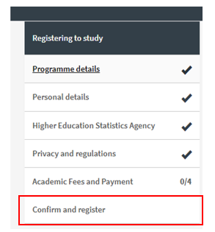

Section B: Pay your student academic fees through My finance channel in MyEd
To make a payment before online student registration opens (no invoice needed), or if payment could not be taken during registration and you receive an invoice, follow the guidance below to make a payment through My finance channel.

- Log into your MyEd portal.
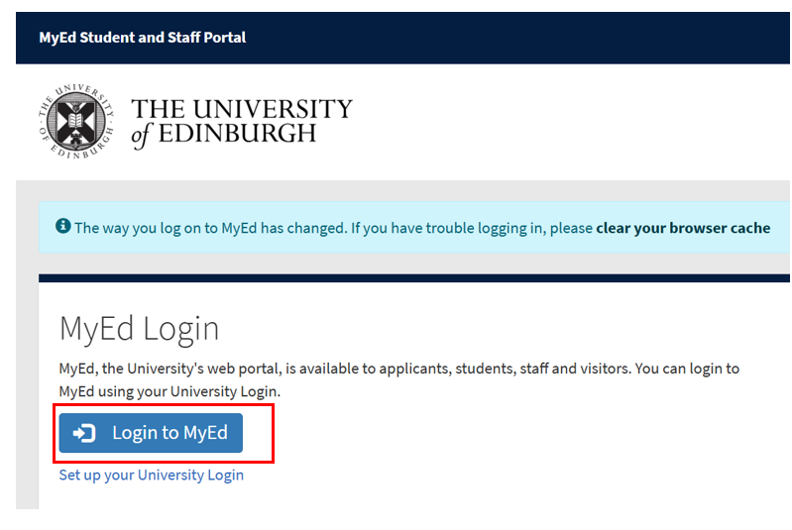
- Navigate to the Accounts tab and select My Finance.

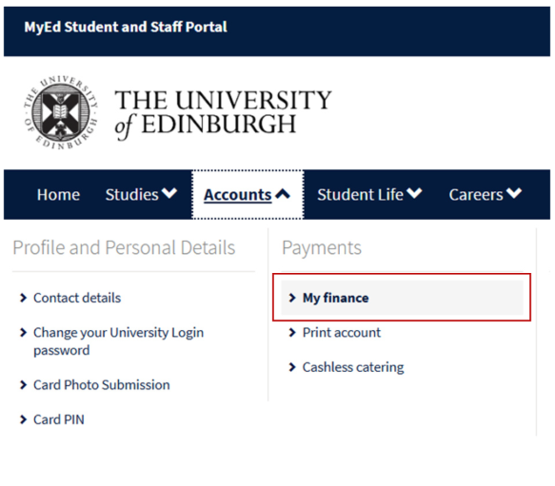
- Click Student Fees to view more details.
If you have any questions about the Student Fees amount displayed, please click the Help button to contact our EdHelp team for assistance.

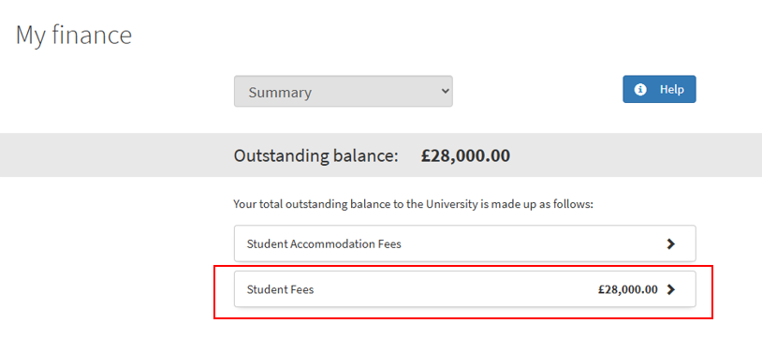

- Review your outstanding tuition fee balance and payment due date. Then, select Payment to proceed to the payment options.

Note: If you choose to pay in instalments, click Register a card for your Recurring Card Payment and follow the on-screen instructions.
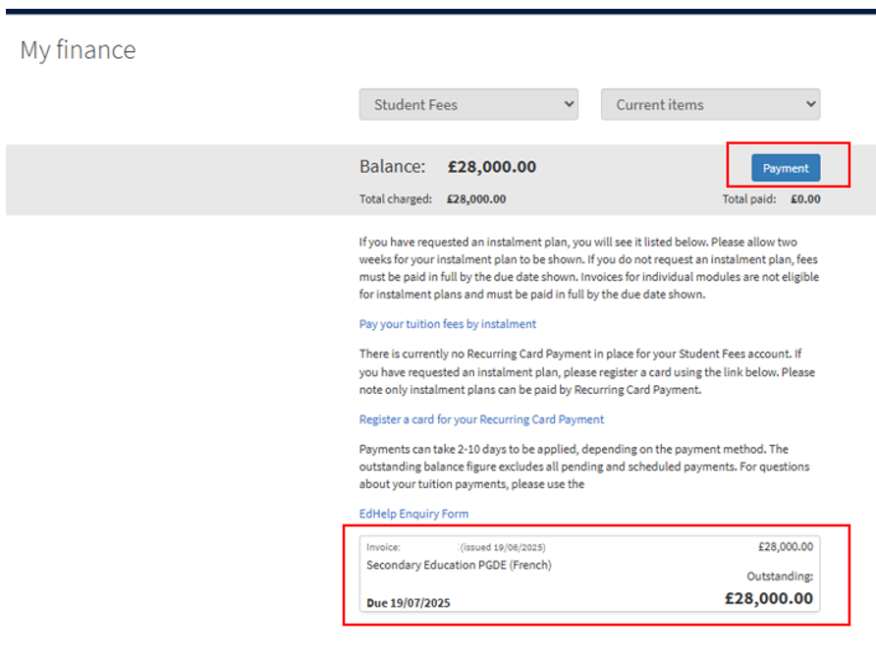

- To pay in full, tick the checkbox next to the invoice details – the checkbox will turn green.

- If you want to pay less than the full invoice amount, select Edit amount, enter the amount you wish to pay, and click elsewhere to confirm.
Verify the amount shown in the Make payment field is correct, then select Pay by bank transfer to proceed.

Note: If no invoice is available on your account yet and you would like to make an advance payment, enter the desired amount in the Make an advance payment section, then select Pay by bank transfer to proceed. To work out how much you need to pay, check out the guidance on our Finance pages: https://uoe-finance.ed.ac.uk/students/fees/self-funded/one-payment
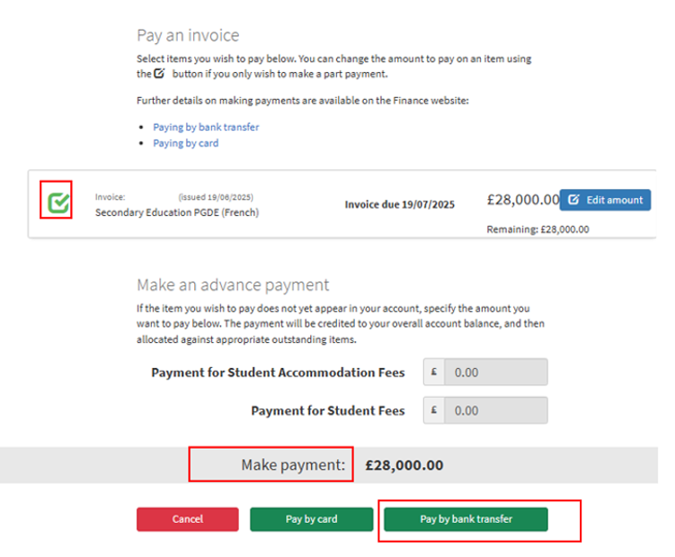

- After selecting Pay by bank transfer, you will see the Flywire Payer Information screen. Your name and student email address will be automatically populated. Fill in the remaining fields, making sure to select the country where the payment originates (e.g., if the payment is being made from a bank account held in the USA, please select United States of America).

Note: If you are a self-funded student and someone else (e.g., a parent or guardian) is paying on your behalf, enter their details instead of yours.
The system will generate a banking instruction for them to use at their own bank. Alternatively, if supported in the country from which the payment originates, you will see an option to make an instant bank transfer using online/mobile banking. Please be aware that this payment option requires the payer to be present to log into their online banking account and authorise the instant payment.
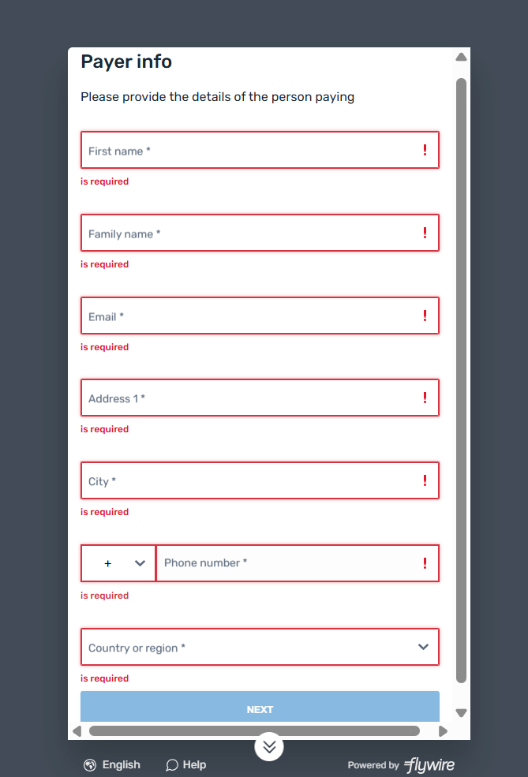

Prefer to complete the payment process in a language other than English? Look for available Language options under the Payer Information screen.
If you need assistance with the payment process, click Help under the Payer Information screen to contact the Flywire support team.
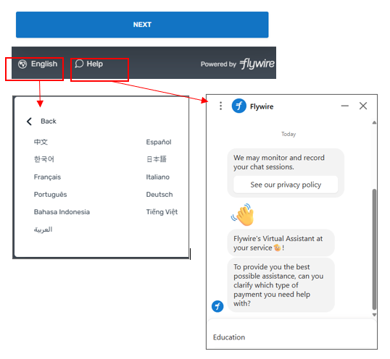
- Based on the information you have provided, you will now see a list of bank transfer options available in your country. Select your preferred option to proceed.
- Domestic bank transfer (available to UK account holders) - lets you generate payment instructions, which you can then use to arrange a payment with your own bank, or provide them to someone else (e.g., a parent or guardian) who is responsible for paying your tuition fees to arrange a payment with their bank.
- Instant bank transfer (supported by most UK banks and some international banks) - enables you to pay directly from your bank account using online and mobile banking. This payment option requires the payer to be present to log into their online banking account and authorise the instant payment.
- International bank transfer (for bank accounts held outside of the UK) lets you generate payment instructions, which you can then use to arrange a payment with your own bank, or provide them to someone else (e.g., a parent or guardian) who is responsible for paying your tuition fees. You will be able to pay in your local currency, or, if not available, to choose another currency supported for your region.
- Online payment methods, (e.g. Alipay, China Union Pay) these function similarly to bank transfers and are available in selected countries

- Domestic bank transfer – Next steps

  - To proceed with a domestic bank transfer, select Domestic bank transfer, agree to the Flywire Terms of Use and Privacy Policy, then click Next
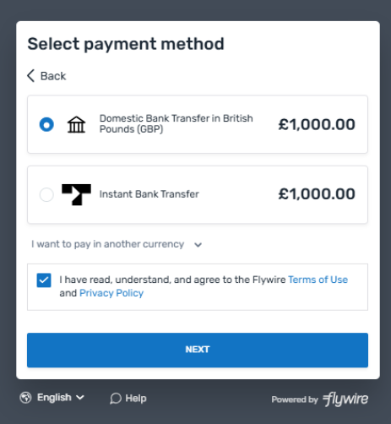

  - Once the system generates your banking instructions with a unique payment reference, click Download payment instructions to save a PDF copy. Finally, scroll down and select I understand I need to initiate a transfer from my bank to finish this part of the process.
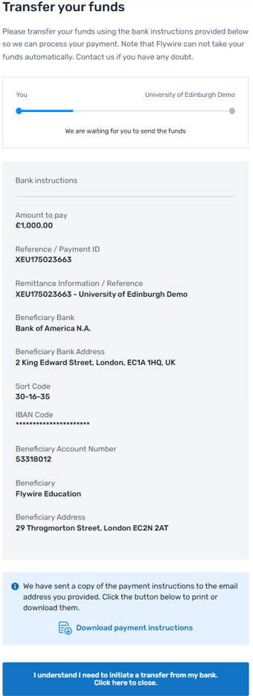
Example payment instructions

  - Now, that you have initiated your bank transfer in MyEd, you will see a confirmation message reminding you to complete the transfer with your bank. Use the payment instructions to complete your transfer in one of the following methods: online or mobile banking, in-person at a bank branch, or telephone transfer.
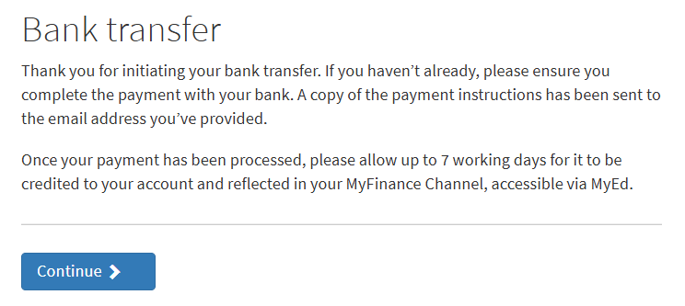

- Below is an example of PDF payment instructions that will be generated for you with a unique reference number. Flywire will also email you a copy of these instructions and send reminders to complete your payment.

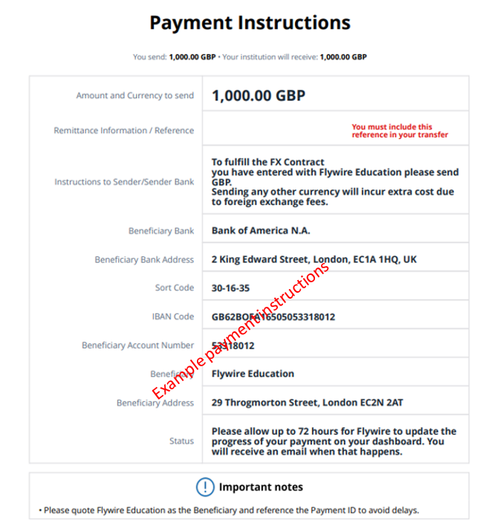
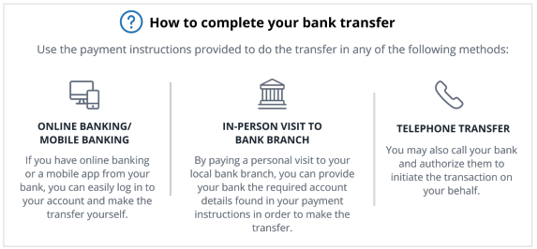

  - Once you have completed the transfer with your bank and we have received your funds through Flywire, your My Finance account will be updated. Please allow 7 business days from the payment date for it to appear in your My Finance channel, accessible through MyEd.
You will be able to view a detailed record of your transactions by selecting Student Fees, then All items in My Finance.
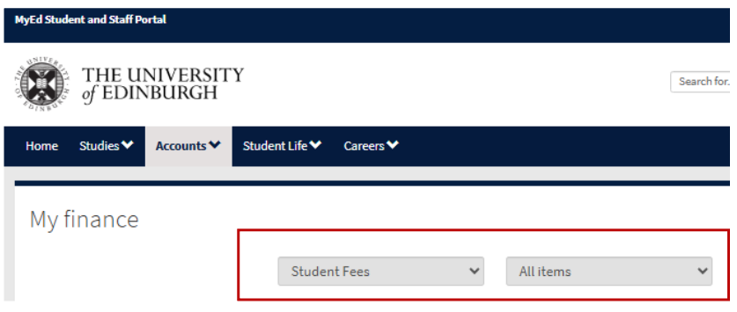
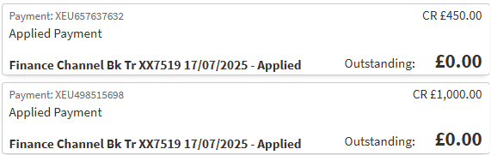

- Instant bank transfer – Next steps

  - To proceed with an instant bank transfer, select Instant bank transfer, agree to the Flywire Terms of Use and Privacy Policy, then click Next.
Please note: if someone else is paying your tuition fees using instant bank transfer, the payer has to be present to log into their online/ mobile banking account and authorise the instant payment.

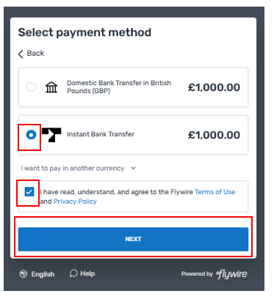

  - Select your country from the dropdown menu at the top right, then choose your bank from the list of available banks.
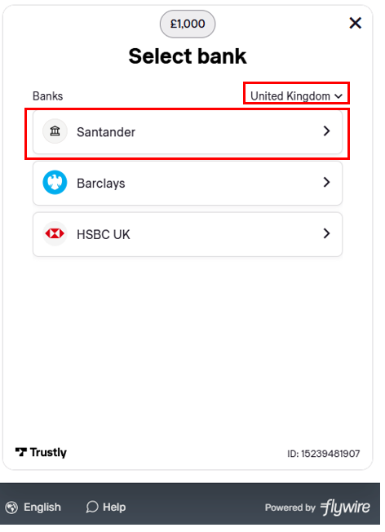

  - Confirm the amount displayed on the screen is correct, then proceed to payment by either opening your bank’s mobile app or selecting Continue on this device, which will redirect you to your bank’s website to complete the payment.
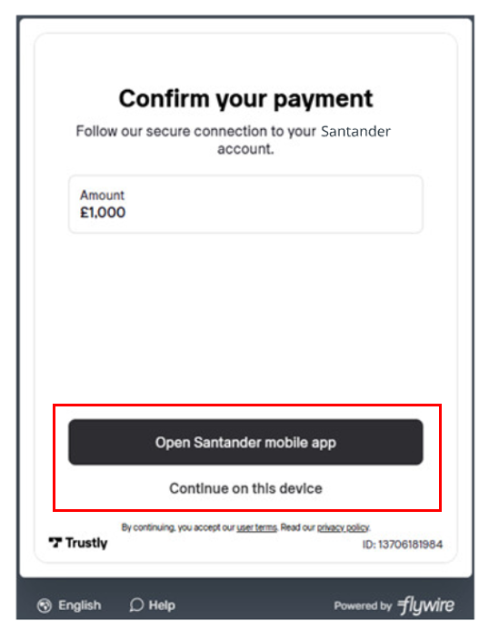

- If you choose to continue using your bank’s mobile app, a QR code will be displayed. Scan the code using your phone’s camera, then follow the prompts in the app to complete your payment.
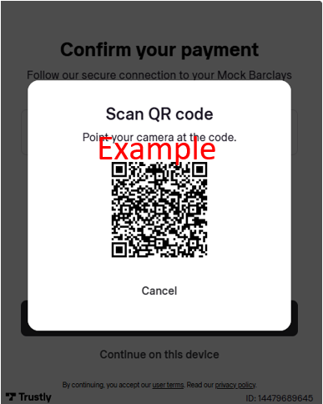

  - After the payment is complete, a confirmation message in MyEd will appear letting you know that once we have received your funds through Flywire, your My Finance account will be updated. Please allow 7 business days from the payment date for it to appear in your My Finance channel, accessible through MyEd.

You will be able to view a detailed record of your transactions by selecting Student Fees, then All items in My Finance.

- International bank transfer – Next steps

  - To proceed with an international bank transfer and pay in your home currency, select International Bank Transfer, agree to the Flywire Terms of Use and Privacy Policy, then click Next.
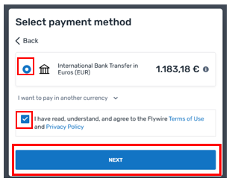

- If your home currency is not available, alternative currencies will be listed for you to choose from, or you can click on I want to pay in another currency and select the preferred currency.

Please note: for this option, make sure you transfer the right currency or you may get charged by your bank for the currency conversion before it sends the funds to Flywire. Flywire will send these funds to the University in pound sterling. If unsure, please check with your bank first.

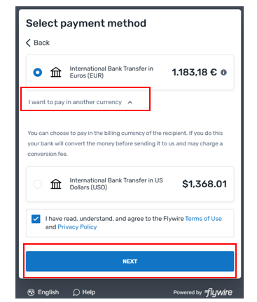

  - You will then see the payment summary showing you the amount to pay. If you are satisfied that the amount is correct, click Continue to payment.
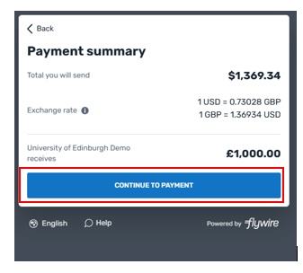

  - Once the system generates your banking instructions with a unique payment reference, click Download payment instructions to save a PDF copy. Finally, scroll down and select I understand I need to initiate a transfer from my bank to finish this part of the process.

- Please note, you may see bank details for a different country to your selected country. This is because Flywire has bank accounts all over the world, including multi-currency accounts which can be supported by different entities (UK, US etc). When you choose to pay in a different currency to your selected country, you may see a different beneficiary account. These are all supported/owned by Flywire and therefore if you see account details displayed in the Flywire payment experience, you can trust they are correct.

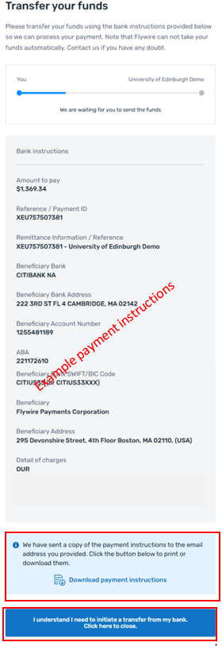

Below is an example of PDF payment instructions that will be generated for you with a unique reference number. Flywire will also email you a copy of these instructions and send reminders to complete your payment before the quote expires.
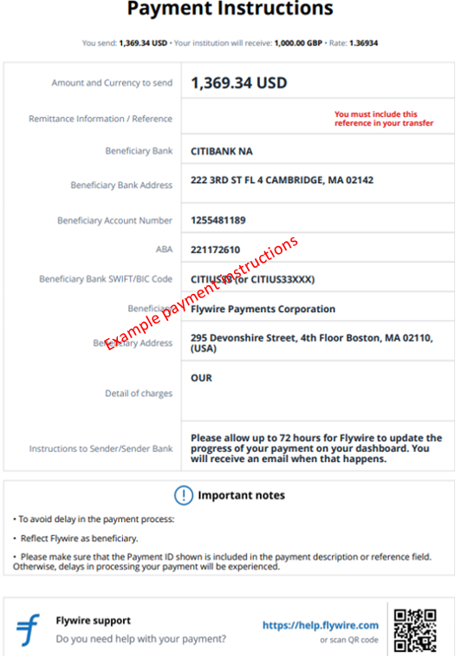

  - Now, that you have initiated your bank transfer in MyEd, you will see a confirmation message reminding you to complete the transfer with your bank. Use the payment instructions to complete your transfer in one of the following methods: online or mobile banking, in-person at a bank branch, or telephone transfer.

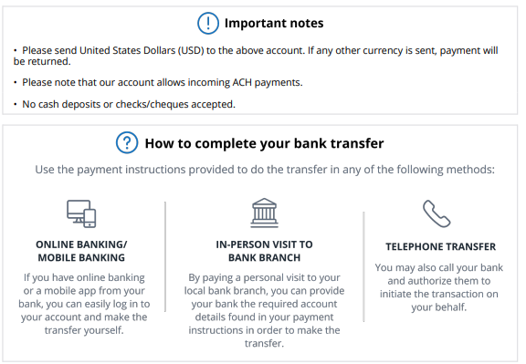
Note: If your bank requests more information prior to autorising the transfer, on the last page of the payment instructions provided by Flywire you will find an Authorisation Letter. This letter explains the relationship between Flywire and the University of Edinburgh and instructs the bank to send funds through Flywire, according to our contractual relationship. If your bank still needs more information, you can always contact the Finance Helpline at finance.helpline@ed.ac.uk

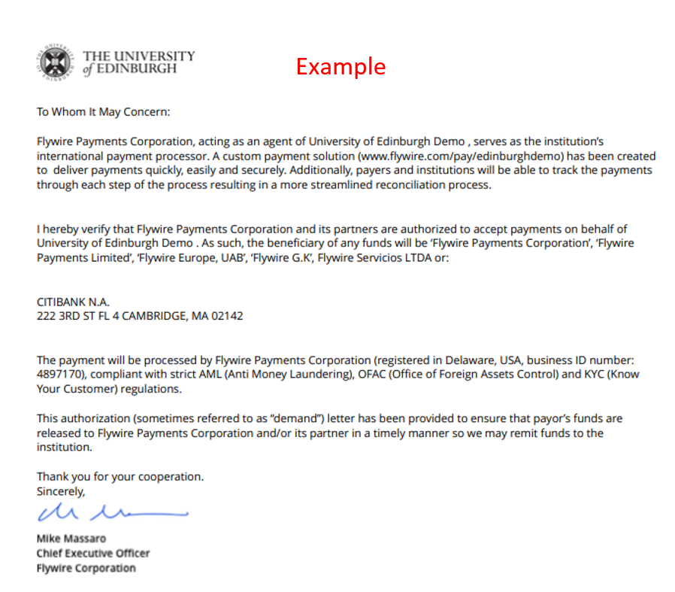

10.5 After you have completed the transfer with your bank and we have received your funds through Flywire, your My Finance account will be updated. Please allow 7 business days from the payment date for it to appear in your My Finance channel, accessible through MyEd.
You can view a detailed record of your transactions by selecting Student Fees, then All items in My Finance.

