Investment assets at 31 July 2025 are comprised of: | Jul-25 |  | Jan-25
 | £ 000's |  | £ 000's
University of Edinburgh Endowment and Investment Fund
Equities | 259,291 |  | 258,010
Fixed interest stocks | 15,979 |  | 17,477
Property | 88,378 |  | 87,520
Multi asset | 157,346 |  | 156,006
Venture capital | 26,735 |  | 28,838
Cash and working capital | 29,852 |  | 6,523
 | 577,581 |  | 554,374
Other investments
Foreign equity | 1,893 |  | 1,794
Fixed interest stocks | 234,089 |  | 359,259
Asset backed security | 103,521 |  | 110,626
Venture capital | 14,070 |  | 16,550
Social investment | 7,101 |  | 7,411
Other investments | - |  | 230
 | 360,674 |  | 495,870
Total investment assets | 938,255 |  | 1,050,244

UNIVERSITY OF EDINBURGH ENDOWMENT AND INVESTMENT FUND
DIRECT HOLDINGS: BAILLIE GIFFORD

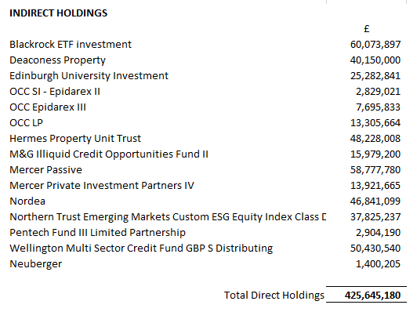

See following pages for information on the type of funds invested in indirect investments. Please note, the above investment listings are from the unaudited financial statements and therefore may be subject to change.

BLACKROCK MSCI WORLD VALUE FACTOR ESG
As at 31 July 2025
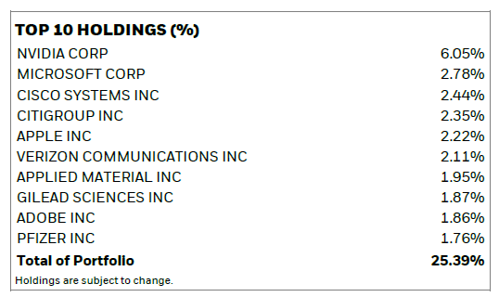

HERMES
As at 31 March 2025
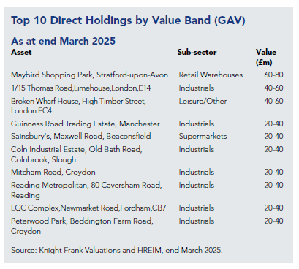

M&G
As at 30 June 2025
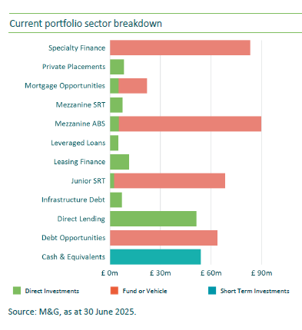

MERCER PASSIVE SUSTAINABLE GLOBAL EQUITY
As at 30 June 2025
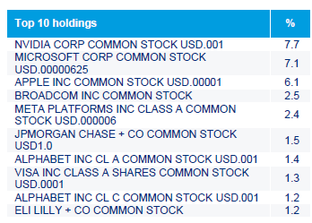

MERCER PIP IV SUSTAINABLE OPPORTUNITIES
As at 31 March 2025
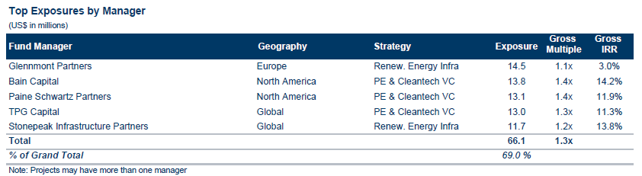

NORDEA
As at 30 June 2025
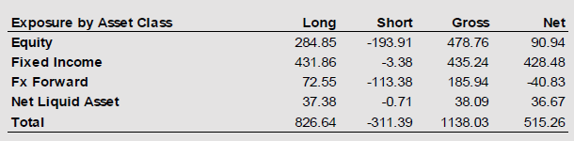

NORTHERN TRUST
As at 30 June 2025
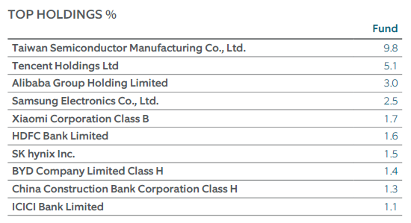

PENTECH
As at 30 June 2025
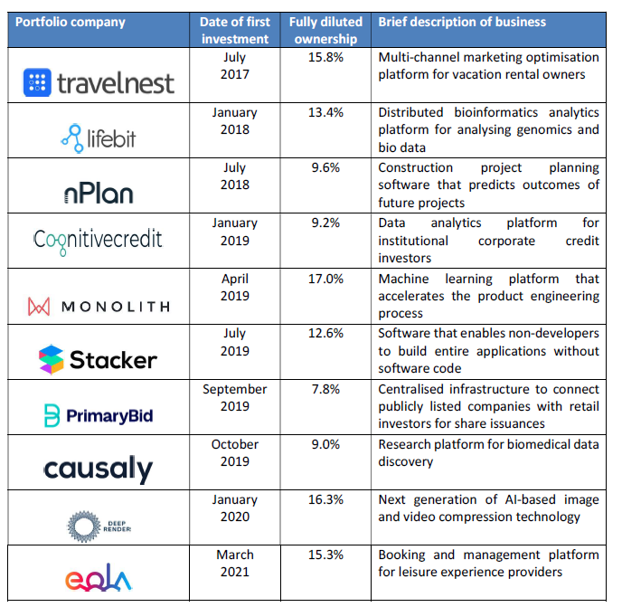

WELLINGTON
As at 30 June 2025
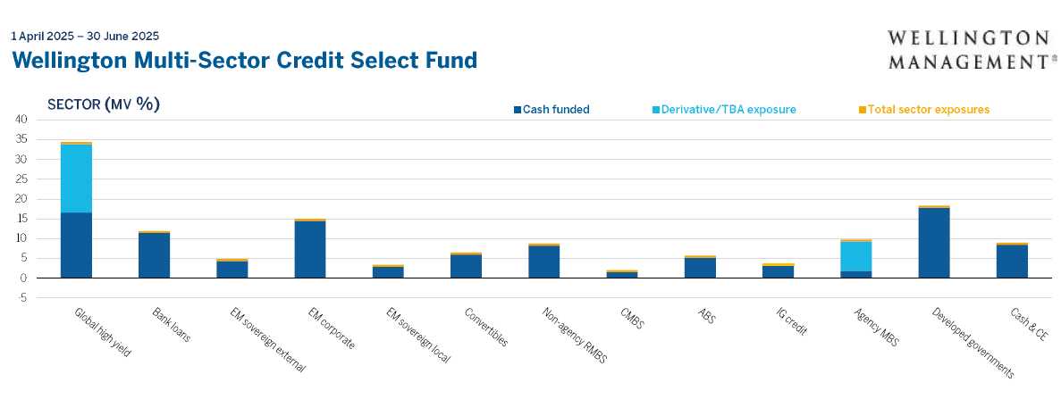

MI TWENTYFOUR INVESTMENT FUNDS – MONUMENT BOND FUND

As at 31 July 2025
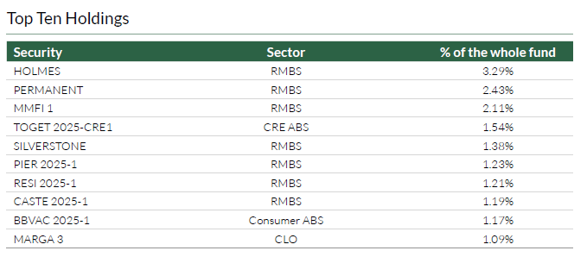

AEGON EUROPEAN ABS FUND I GBP HDG

As at 30 June 2025
