Investment assets at 31 January 2026 are comprised of: | Jan-26 |  | Jul-25
 | £ 000's |  | £ 000's
University of Edinburgh Endowment and Investment Fund
Equities | 278,172 |  | 259,291
Fixed interest stocks | 13,918 |  | 15,979
Property | 40,150 |  | 88,378
Multi asset | 179,125 |  | 157,346
Venture capital | 29,909 |  | 26,735
Cash and working capital | (2,473) |  | 29,852
Money market funds | 69,377 |  | -
 | 608,178 |  | 577,581
Other investments
Foreign equity | 2,029 |  | 1,893
Fixed interest stocks | 343,044 |  | 234,089
Asset backed security | 106,289 |  | 103,521
Venture capital | 15,673 |  | 14,070
Social investment | 6,987 |  | 7,101
Other investments | - |  | -
 | 474,022 |  | 360,674
Total investment assets | 1,082,200 |  | 938,255

UNIVERSITY OF EDINBURGH ENDOWMENT AND INVESTMENT FUND
DIRECT HOLDINGS: BAILLIE GIFFORD as at 31 January 2026
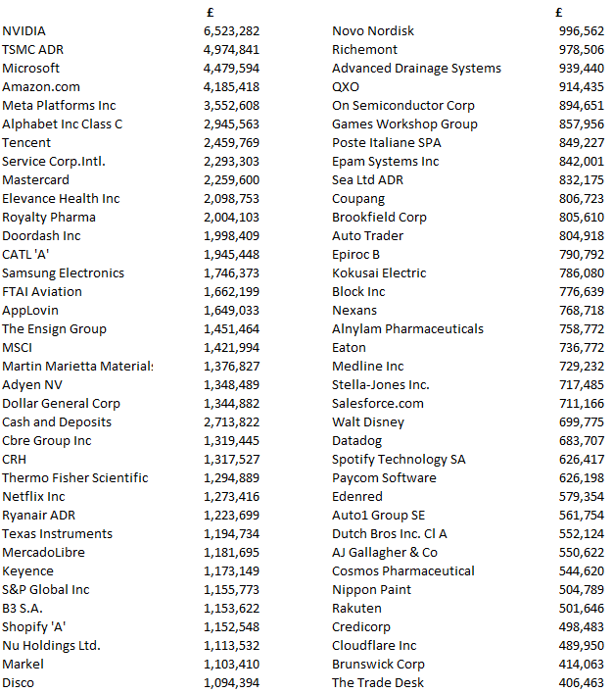
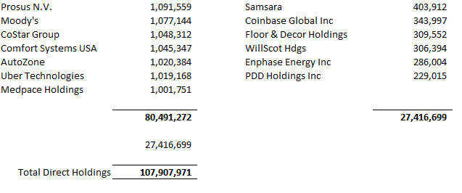

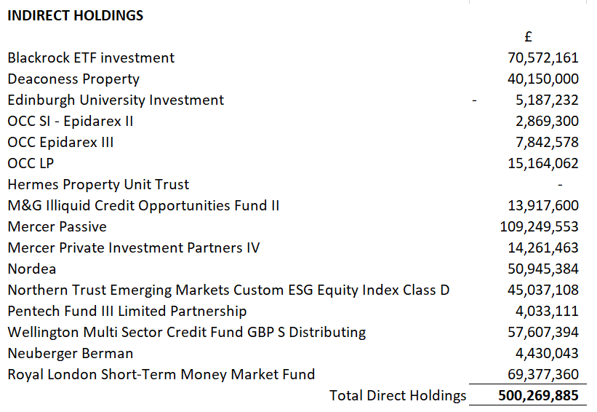
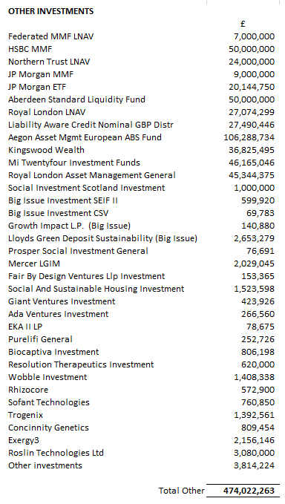

See following pages for information on the type of funds invested in indirect investments.

BLACKROCK MSCI WORLD VALUE FACTOR ESG
As at 31 December 2025
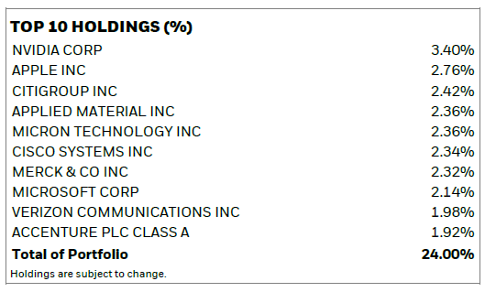
M&G
As at 30 September 2025
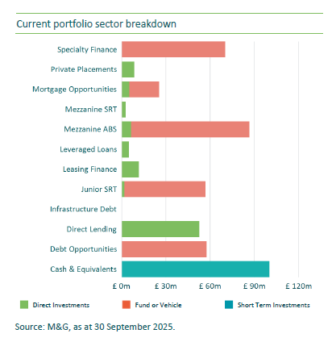

MERCER PASSIVE SUSTAINABLE GLOBAL EQUITY
As at 31 December 2025
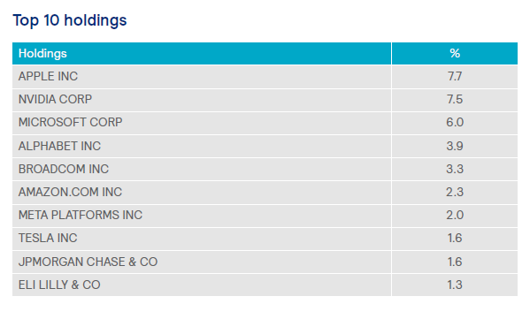
MERCER PIP IV SUSTAINABLE OPPORTUNITIES
As at 30 September 2025
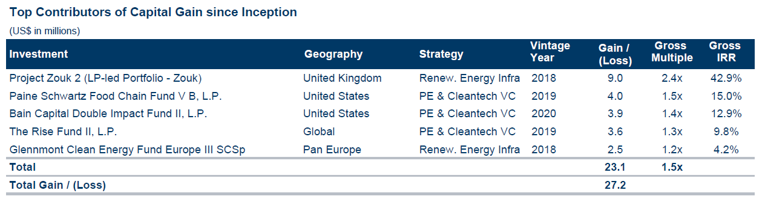
NORDEA
As at 31 December 2025
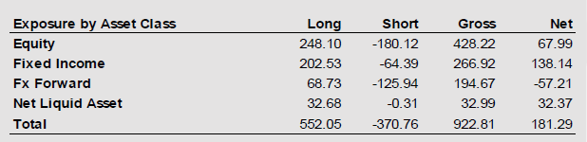

NORTHERN TRUST
As at 31 January 2026
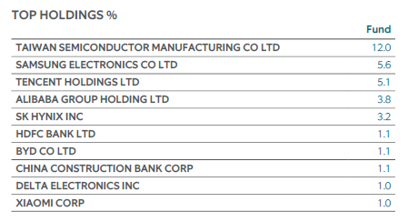

PENTECH
As at 31 December 2025
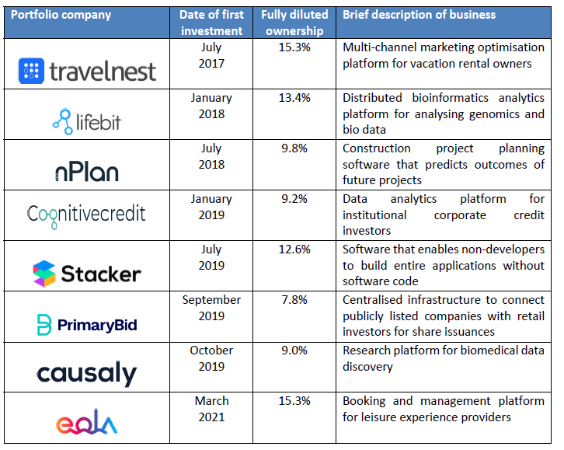

WELLINGTON
1 October 2025 - 31 December 2025
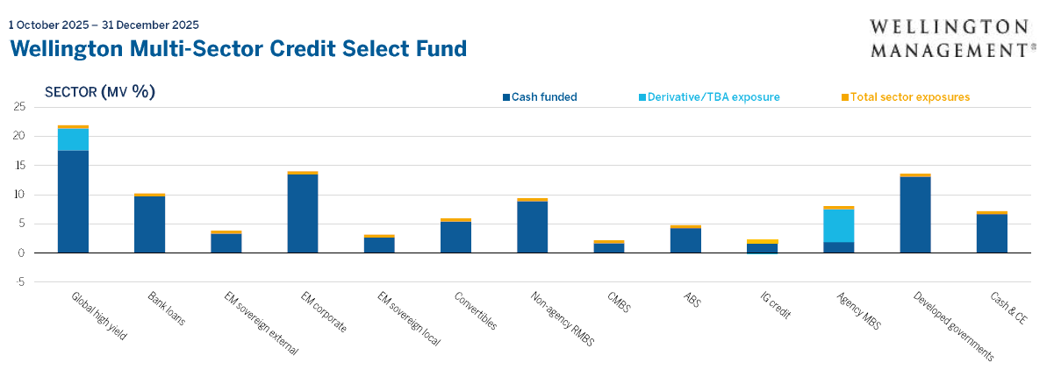

MI TWENTYFOUR INVESTMENT FUNDS – MONUMENT BOND FUND

As at 31 December 2025
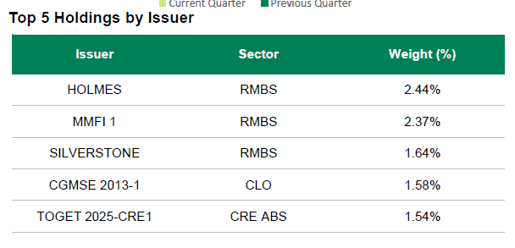

AEGON EUROPEAN ABS FUND I GBP HDG

As at 31 December 2025
